## Exercise 06: Making a medical questionnaire (5) - Advanced field functions

* Create the calculated field to determing the weekly dosage of the prescribed medicine:

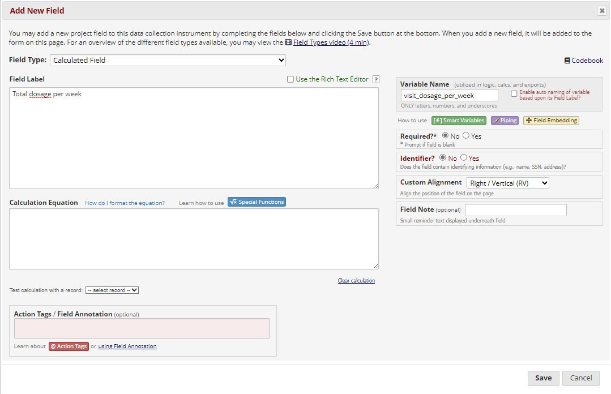

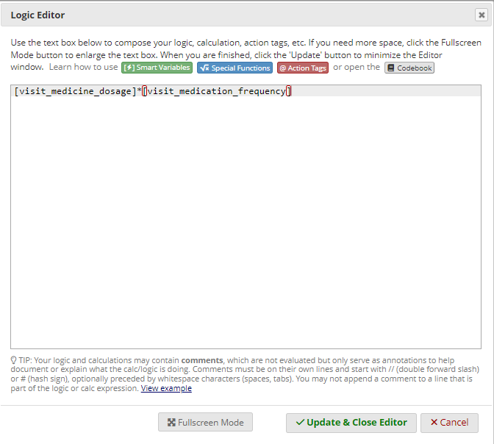

* Hide the calculated field using action tags:

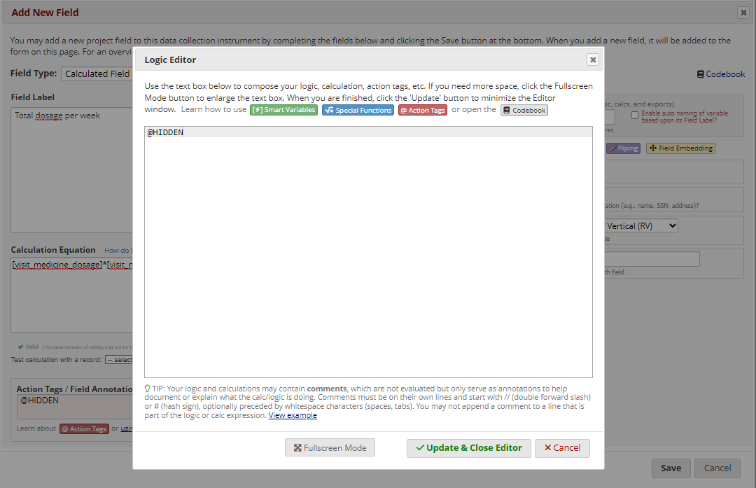

* Create a short text field to record which other medicine may have been prescribed.

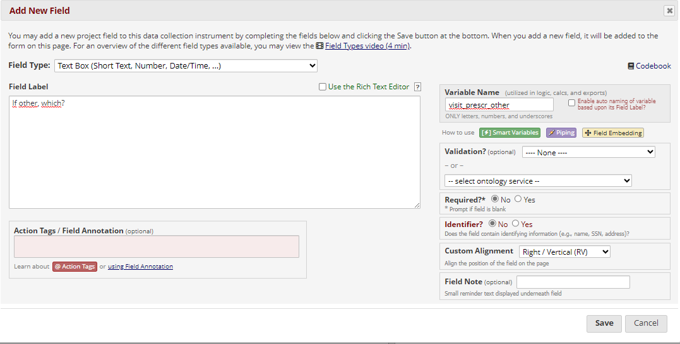

* Add a branching logic condition, to hide the field unless the doctor indicates “other” under the medicine choice.

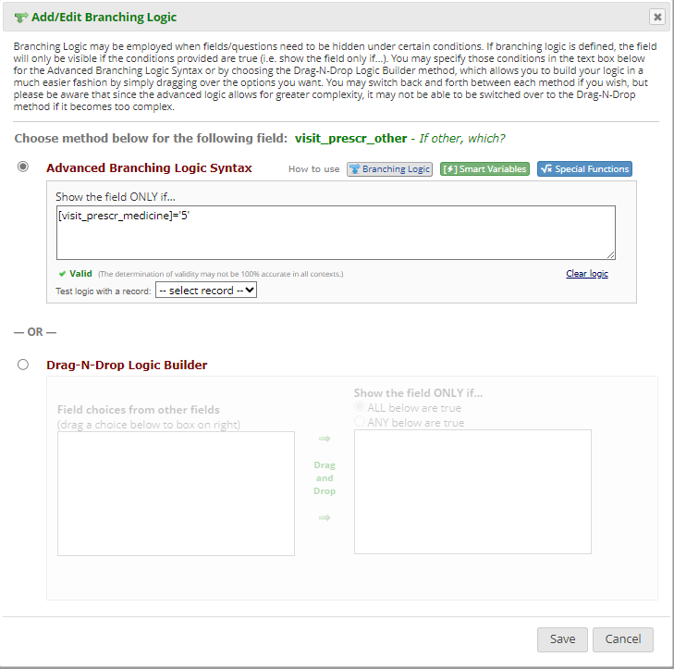

* Embed the “Other” question in the previous (multiple choice) question:

